Lab 6 Zhuoyang Chen 10/04/2019

The FitzHugh-Nagumo Model

1. Model

The FHN model is a simplified model for HH model simulating the firing and resting of membrane potential.

$$\dot{x}=c(x-\frac{x^{3}}{3}-y+S(t))$$

$$\dot{y}=\frac{x+a-by}{c}$$

x here reflects the membrane potential, y corresponds to the recovery process and S(t) is the applied stimulus to trigger the action potential.

In this lab, we used the ode15s solver to deal with the FHN model, a stiff system, which the x variable changes faster and y variable changes much slower. Compared to ode45 solver, the ode15s would allow a bigger error to adjust the step size to reduce the steps to simulate the equation. In a stiff system like FHN, it would take a long time when using ode45 to simulate when the change rate of the variable (like x) is small. Sometimes it would take a minute to simulate for only one period. This problem is clearly illustrated as below:

Using ode45 Using ode15s

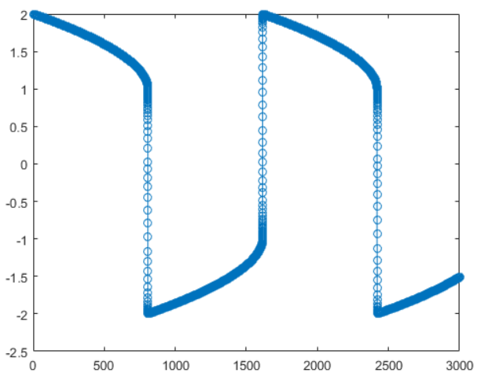 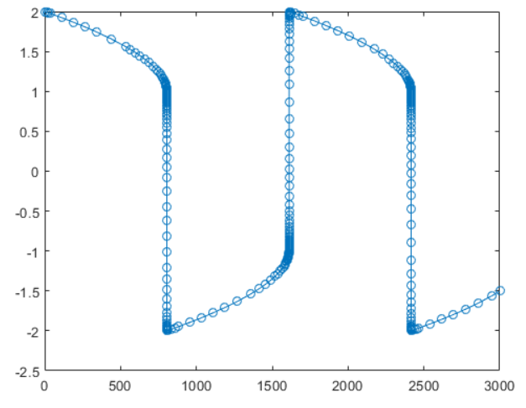

(figures from **mathworks**)

In general, using ode15s would be much faster to solve stiff system. Noted that in this lab, the options includes a Maxstep argument:

options **=** odeset**(**'RelTol'**,**1e-8**,**'Maxstep'**,**0.1**);**

**[**t**,**y**]** **=** ode15s**(@**FHNeqns**,[**0 t_end**],**y0**,**options**);**

The Maxstep defined here is to avoid enlarging the time step too much and stepping over a period of interest. The usage of ode15s is almost the same as ode45.

2. Baseline run

Set parameters as a=0.7, b=0.8 and c=3.0, the results figures are shown as below:

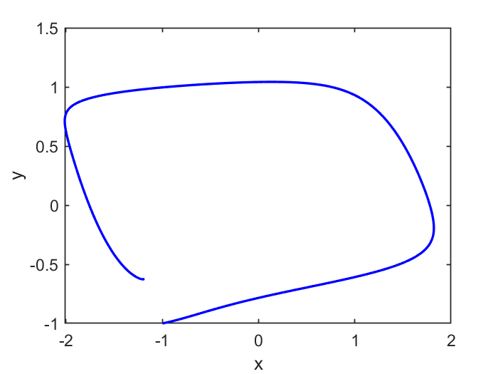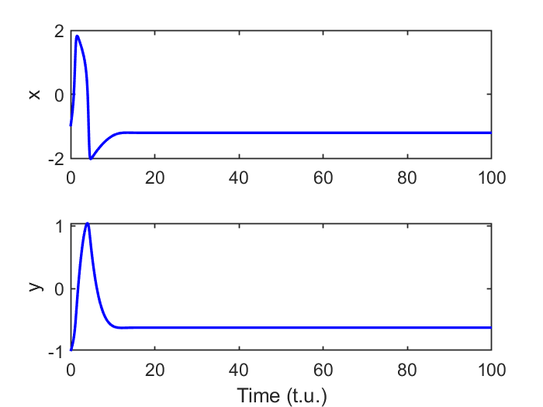

The trajectory in the phase plane shows that it starts at initial condition (-1, -1), moves spirally counter-clockwise and finally reaches the fixed point. From the time scale figure on the right, the x (membrane potential) generates a spike, representing an action potential. As x increases, y gradually increases to help recovery, and as y right after reaching its peak, x is repolarized and reaches its lowest point. At last y decreases, and x approaches to the fixed point, the resting potential.

Then I varied the initial conditions to verified that there is only one fixed points:

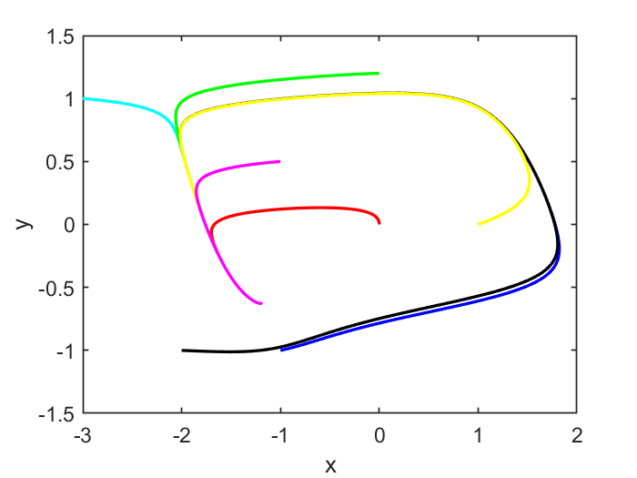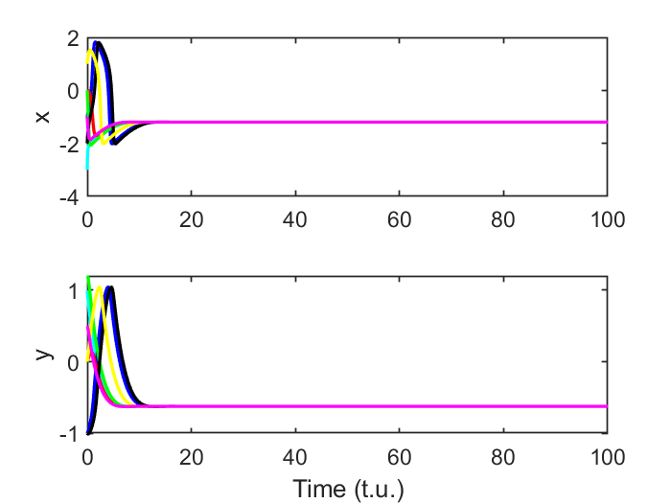

The results convinced me that there is only one fixed point. The fixed point reflects the resting potential of cytoplasmic membrane and any excitation of potential will in the end restore the resting potential.

3. Fixed point

From last section, we can estimate that the fixed point is -2 ~ -1 for x and -1 ~ 0 for y. To find the eigenvalues and compute the fixed point, I first found the nullclines for the system:

$$y=x-\frac{x^{3}}{3}+S(t)$$

$$y=\frac{x+a}{b}$$

Using S(t) = 0 and a=0.7, b=0.8 and c=3.0, we have $x-\frac{x^{3}}{3}=\frac{x+0.7}{0.8}$.

To use rootsfunction, organized the equation as $x^{3}+\frac{3}{4}x+\frac{21}{8}=0$, and pass the coefficients of the polynomials:

roots**([**3 0 3**/**4 21**/**8**]);**

I got x = -1.1994, and computed that y = -0.62426;

The Jacobian matrix of the system is:

J **=** **[**3**-**3**\***x**^**2 **-**3**;** 1**/**3 **-**4**/**15**]; %%(fixed point x)**

$$J=\left(\begin{matrix}-1.3157 & -3 \\ 0.3333 & -0.2667\end{matrix}\right)$$

Used the *eig(J)* function and got

ans =

-0.7912 + 0.8514i

-0.7912 - 0.8514i

With $τ$ less than 0, the fixed point is a stable spiral, which is confirmed by the figures above.

4. Excitability

Set amp=1.0, dur=0.5 and tstart=5 to introduce a small stimulus for the system, use the fixed point (-1.1994, -0.62426) as the initial condition. Here we both test the excitability with amp=0 as above and amp=1.0.

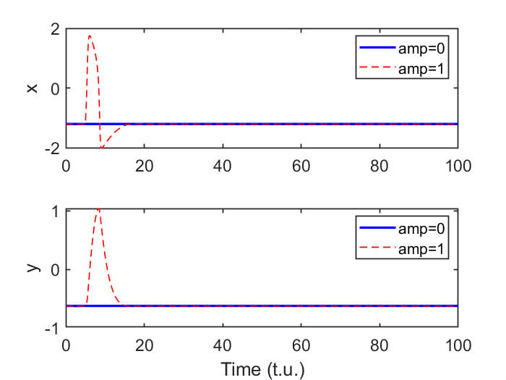

The red dash is amp=1 and blue solid line is amp=0. When no trigger stimulus, the potential is right just at the fixed point. When amp=1, the small stimulus triggers a large response. What we should pay attention to is that at the beginning we used the initial value (-1, -1) is kind of mimic the triggering effect of the stimulus and in fact there is no stimulus at that case, as amp=0.

However, if the value of amp is under than a certain threshold, the action potential would not be triggered. I simulated the solution using amp=0.3, the result is shown as below:

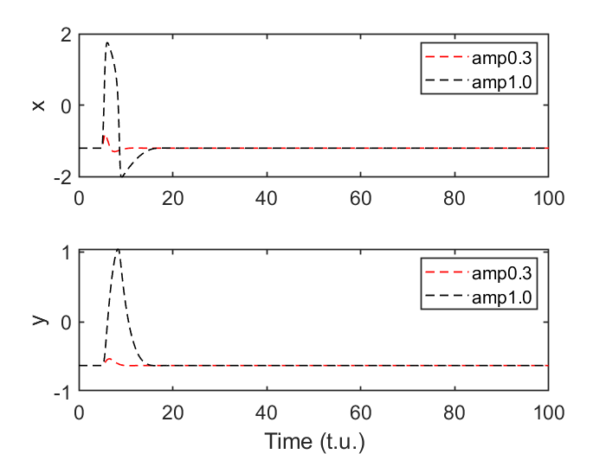

In the amp=0.3 case, the stimulus just cases a very slight fluctuation, fails to trigger a action potential.

To explain the difference of triggering effect with different amp values, I added the nullclines of S(t)=0 (before and after the stimulation) to the phase plane plot of amp=0.3 (subthreshold) and amp=1.0 (suprathreshold). Figures are shown as following:

amp=1.0

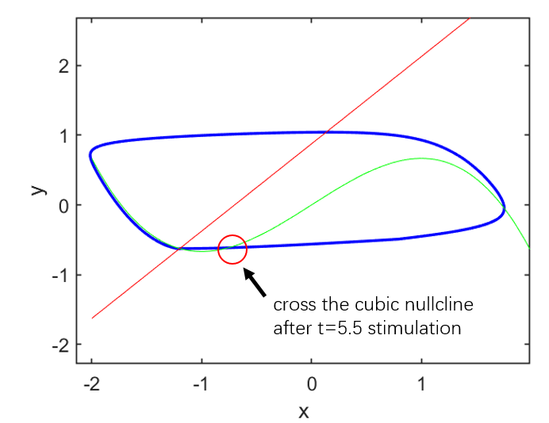

amp = 0.3

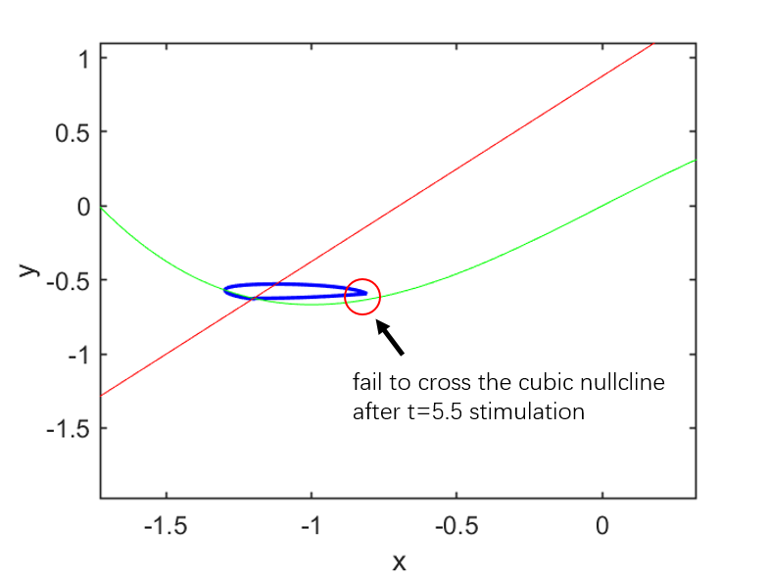

The reason why the trajectory failed to make a larger excursion along the right part of the cubic nullcline can be explained by inspecting the time serial data during the stimulation, which starts at t=5.0 and lasts for 0.5. The purpose to introduce a stimulus is to shift the initial resting potential away from the fixed point of the system.

As we carefully look at the nullcline:

$$y=x-\frac{x^{3}}{3}+S(t)$$

an increasing value of S(t) would make the cubic nullcline move upward, leading to a higher position of fixed point created by the intersection of the cubic and linear nullclines. This movement shifts the initial values away as the new fixed point has changed, and trajectory starts to move rightward.

As the stimulation ends, the system restores its original properties and the movement of the trajectory is determined by the nullclines. If the trajectory fails to cross the cubic nullcline at t=5.5, it would turn to the up left and cross the linear nullcline, prevented to a further excursion, as we see at amp=0.3; if the trajectory crosses the cubic nullcline as seen in figure of amp=1.0, it can go further to cross the cubic nullcline again at the right part, making a larger excursion.

To explore the effect of various amp values, I tested amp=0.3, 0.4, 0.45 and 0.5, and plot the solutions as below:

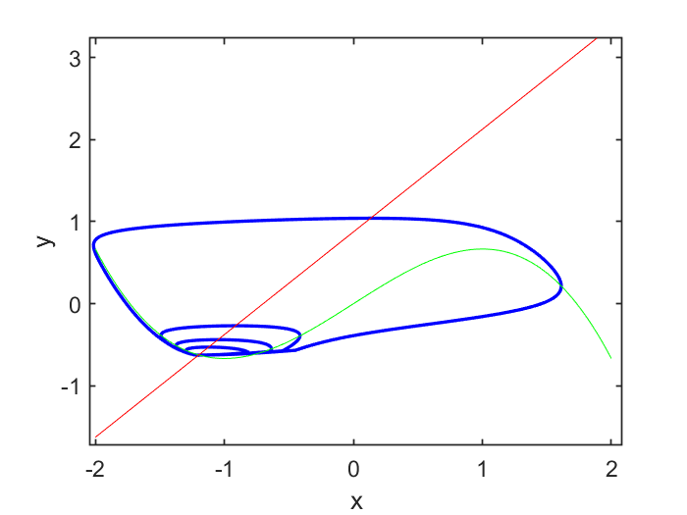

The figure confirms my explanation that whether the trajectory crosses the cubic nullcline determines a larger excursion. The spiral from inside to outside is amp=0.3, 0.4, 0.45 and 0.5 respectively, and the unsmooth point (a slight turn) near the cubic nullcline at the beginning indicates the end of the stimulation t = 5.5. Although when amp=0.45 the trajectory indeed crosses the nullcline, but it just make a slightly larger excursion compared to amp=0.4, while when amp=0.5, a much larger excursion occurs, which means how far the trajectory beyond the cubic nullcline also determines how large a excursion would be.

5. Refractoriness

To investigate the coupling interval between the two action potentials, I simulated the solution with different stimulus interval. A second stimulus was created by introducing a later *tstart* value, and using the same *dur* and *amp* values. The code is illustrated as below:

**function** dydt **=** FHNeqns**(**t**,**y**)**

a **=** 0.7**;**

b **=** 0.8**;**

c **=** 3.0**;**

amp **=** 1.0**;**

dur **=** 0.5**;**

tstart **=** 5.**;**

interval**=**16**;**

S**=**0**;**

**if** **(**t**>**tstart **&&** t**<**tstart**+**dur**)**

S**=**amp**;**

**end**

**if** **(**t**>**tstart**+**interval **&&** t**<**tstart**+**interval**+**dur**)**

S**=**amp**;**

**end**

dydt **=** **[**c**\*(**y**(**1**)-**1**/**3**\***y**(**1**).^**3**-**y**(**2**)+**S**);** **(**y**(**1**)+**a**-**b**\***y**(**2**))/**c**];**

**end**

(a) interval = 3.0 (b) interval = 3.5

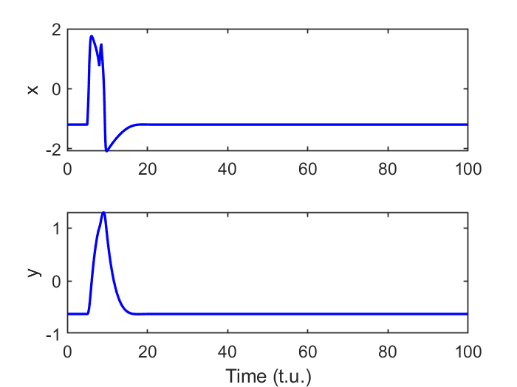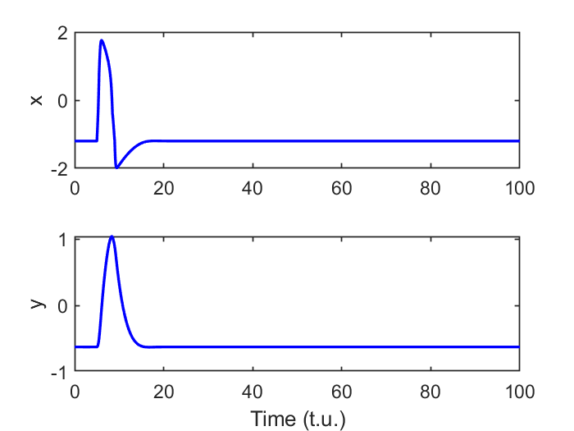

(c) interval = 6.0 (d) interval = 11

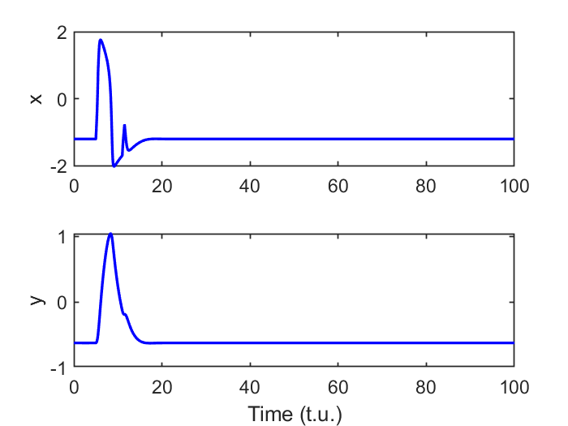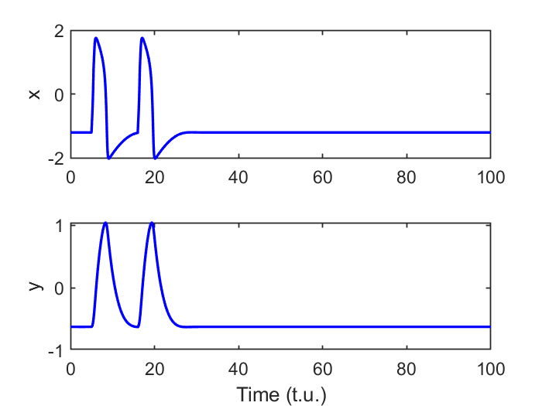

As results above indicates, different intervals would cause different responses from the first pulse. (a) The second stimulus at the early phase of the first pulse may further generates a peak after the first pulse. (b) The second stimulus at the late falling edge of the first pulse may fail to cause any effective disturbance. (c) The second stimulus at the late repolarization phase may fail to generate an action potential. (d) The second stimulus may successfully generate a second action potential when the potential is almost or already at the resting value.

We can see that in figure (b) which doesn’t have effective disturbance, there is no coupling interval, while in figure (c) which generate a second pulse would have a coupling interval.

The figure (b) reflects the refractoriness.

6. Latency

In the case of interval = 12, latency from the onset of stimulus pulse t=5 to peak of the action potential t=6.0612 is around 1.0612. The second stimulus starts at t=17, and the latency for a second action potential is 18.0455 – (5 + 12) = 1.0455.

Decrease the interval to 11.5, latency becomes 6.0612 – 5 = 1.0612 for the first pulse and

17.5604 – (5 + 11.5) = 1.0604 for the second pulse.

Further decrease the interval to 11, becomes 6.041 -5 = 1.041 for the first pulse, and

17.0608 – (5 + 11) = 1.0608 for the second pulse.

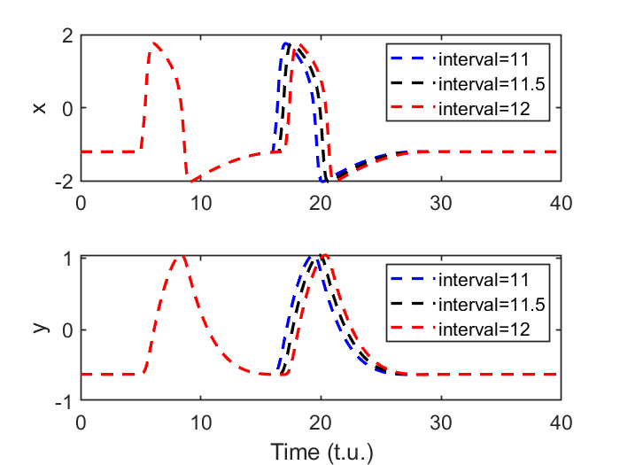

As the interval between the first and second stimulus decreases from 12 to 11.5 to 11, the latency is increasing from 1.0455 to 1.0604 to 1.0608.

It takes time for the potential to restore a rest phase. It is reasonable to think that as the interval decreases, there is not enough time for the potential to increase approaching the rest potential at -1.1994. Through careful inspect of the time serial data, when interval decreasing, the potentials when a second stimulus introduced are -1.1980, -1.2032 and -1.2125, respectively. The shorter the interval is, the longer it takes to reach the same action potential from a lower position.